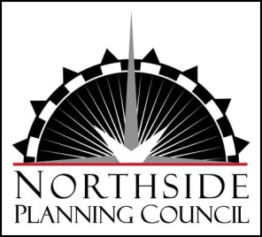
MONTHLY NPC BOARD MEETING
Wednesday, August 20, 2014 6:00–7:30 pm
WPCRC Meeting Room
AGENDA
- Announcements

- Approval of Agenda/ Approval of Minutes

- Board Business
  - Strategic planning and fundraising planning timeline (Walt & Sue)
  - City Emerging Opportunities grant – Race to Equity Forum (Karen)

- Treasurer’s Report

- Chair Report
  - Board member fundraising contributions
  - Board liaison assignments to NPC projects & programs
  - North Star Award planning update – save Dec. 4th date

- Executive Director Report
  - NEDC Activities
    - Happy Hour
    - ShopKo building promotions
    - Interactive Northside map
  - Donor/volunteer management database purchase

- Executive Session

- Wrap-up and Adjourn

Upcoming meetings/events
August 22 – Warner Beach House mural community painting day, 9 am - Noon
August 25 – Entrepreneurs Happy Hour at FEED, 4:30 – 7 pm
Sept 6 (or 7) – Street Mural Community Painting Day – Knutson Drive circle, 8 am – 6 pm
Sept 7 – Warner Beach House mural community painting day, 9 am – Noon
Sept 10 – Northside United, 5:30 – 7 pm

